Transfer Learning for Binary Smile Classification on CelebA Dataset

Colab Notebook Link:

https://colab.research.google.com/drive/120MDTmTd0etKKFm8AWCv_12M0Uo3mhAf?usp=sharing

Elif Zorlu

1. Introduction

In this project, the main goal is to explore transfer learning for binary smile classification, determining whether a person is smiling or not in an image using a VGG-16 pre-trained model.

Instead of training a deep Convolutional Neural Network from scratch, which requires massive datasets and computational resources, we use the VGG-16 architecture pretrained on ImageNet. Transfer learning allows us to leverage learned feature representations (edges, textures, shapes etc.) and adapt them to our specific facial attribute task, rather than starting from zero.

We explore two distinct approaches: the first involves utilizing the pre-trained model as a fixed feature extractor, where only the final classification layer undergoes training. The second approach allows the last convolutional block of the feature extractor to adapt alongside the classifier. Additionally, we investigate the impact of data augmentation on model performance. All models are trained for 10 epochs and evaluated on separate validation and test datasets.

2. Methodology

2.1 Dataset Preparation
The Celeb30k dataset consists of 30,000 images from the CelebA dataset.
- Preprocessing: All images were resized to 224×224 pixels to match the input requirements of VGG-16. Pixel values were normalized using mean [0.5, 0.5, 0.5] and standard deviation [0.5, 0.5, 0.5].

- Data Splitting: To ensure robust evaluation, the data was stratified and split as following:
  - Training: 80% (24,000 images)
  - Validation: 10% (3,000 images)
  - Test: 10% (3,000 images)

- Data Augmentation: To prevent overfitting and improve robustness, the following data augmentations were applied only to the training set:
  - RandomHorizontalFlip(p=0.5)
  - ColorJitter(brightness=0.15, contrast=0.15)

2.2 Model Architecture
For architecture, the VGG-16 model provided by torchvision was used.
- Base: The convolutional layers were initialized with ImageNet weights.
- Head: The original 1000-class classifier was modified. The final fully connected layer was replaced with nn.Linear(4096, 1) to output a single logit.
- Loss Function: BCEWithLogitsLoss was used (which combined Sigmoid and Binary Cross Entropy) for numerical stability.
- Optimizer: Adam optimizer was used with a learning rate of 1e-4.

2.3 Experimental Setup

Two training strategies over 10 epochs were compared as follows:
Strategy A (Frozen Features):
- All convolutional layers (model.features) were frozen (requires_grad=False).
- Only the classifier layers were updated.
- Hypothesis: While this strategy trains faster, it may lack the specificity depth for subtle facial expressions.
Strategy B (Fine-Tuning Last Block):
- The first four convolutional blocks remained frozen.
- Block 5 (the final convolutional block) and the classifier were unfrozen.
- Hypothesis: Unfreezing the deeper layers allows the model to adjust high level features such as mouth shape, cheek structure etc. specific to the "smiling" attribute, which potentially improves accuracy.

3. Results

3.1 Visualizations
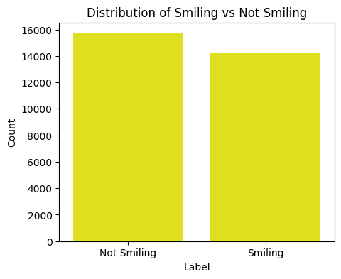
Fig 1.1 Distribution of smiling vs. not-smiling labels in the dataset.

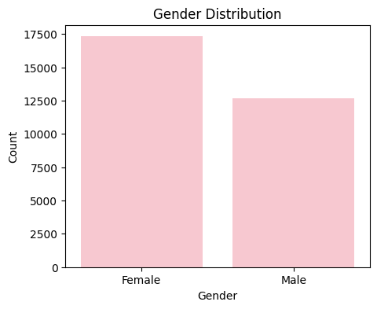
Fig 1.2 Gender distribution of the CelebA subset

The dataset contains more female than male samples, and the smiling attribute is moderately imbalanced but not severely skewed. This suggests the model does not require heavy balancing strategies, although augmentation helps alleviate the minor bias.

3.2 Model Performance Comparison

Model Strategy | Training Loss | Best Validation Accuracy | Best Validation Loss | Training Time
Model A (Frozen) | 10.21% | 86.23% | 32.60% | 18 mins
Model B  (Fine-Tuned) | 17.10% | 92.57% | 18.77% | 21 mins

Table 1.1

3.3 Loss Curves
The training and validation loss curves for the models are shown below. The curves demonstrate that the model converged effectively without significant overfitting.
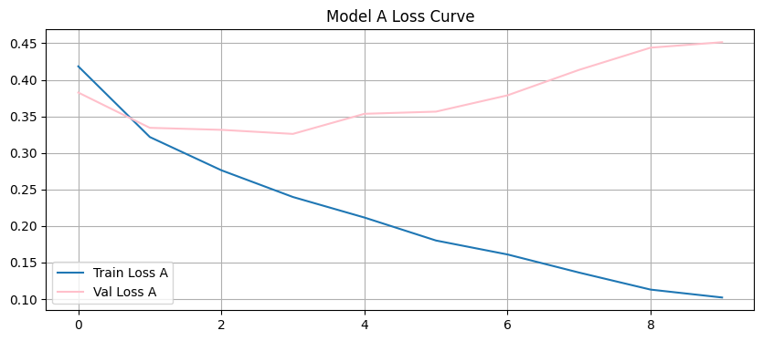
Fig 1.3 Training and validation loss curves for Model A (Frozen)
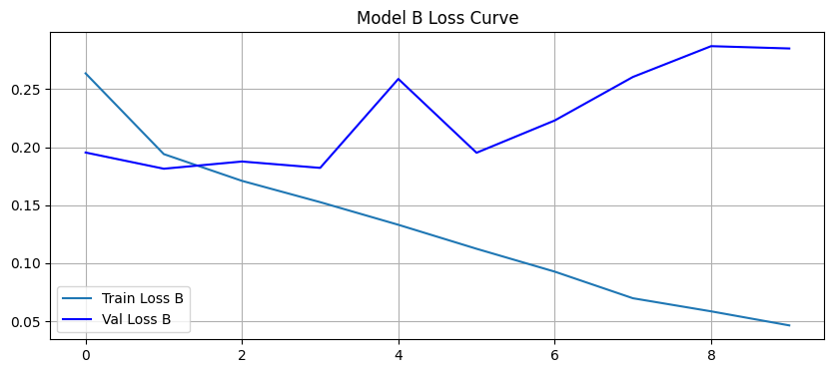
Fig 1.4 Training and validation loss curves for Model B (Fine-tuned)

In Fig 1.3, Model A shows early signs of overfitting after epoch 3, where validation loss begins to increase while training loss continues decreasing. In Fig 1.4, Model B, however, maintains lower validation loss and shows more stable convergence, confirming that fine-tuning improves generalization.

3.4 Final Test Evaluation
Based on the validation results, Model B was selected as the optimal model.
- Final Test Accuracy: 91.77%

Confusion Matrix: The confusion matrix below illustrates the model's performance on the Test .
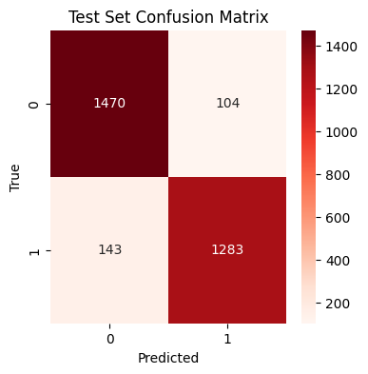
Fig 1.5. Confusion matrix for the selected model (Model B)
Fig 1.5 displays the confusion matrix for the best-performing model (Model B) on the Test Set. The high values along the main diagonal confirm the model's effectiveness, with the general majority of 'Smiling' and 'Not Smiling' faces being correctly classified. The relatively low number of false positives and false negatives indicates that the model maintains a balanced performance without significantly biasing toward one class over the other.

Qualitative Results:
- Correct Predictions: The model successfully identified smiles in various poses and lighting conditions.
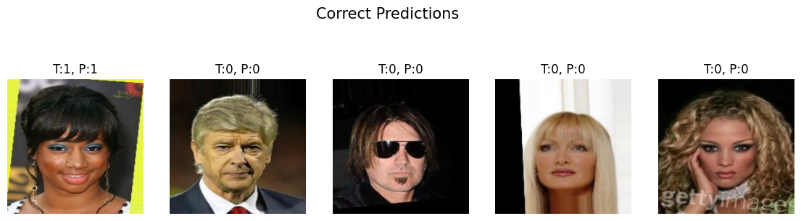
- Incorrect Predictions: Errors mostly occurred in ambiguous cases, such as faint smiles, occluded mouths, or extreme angles.
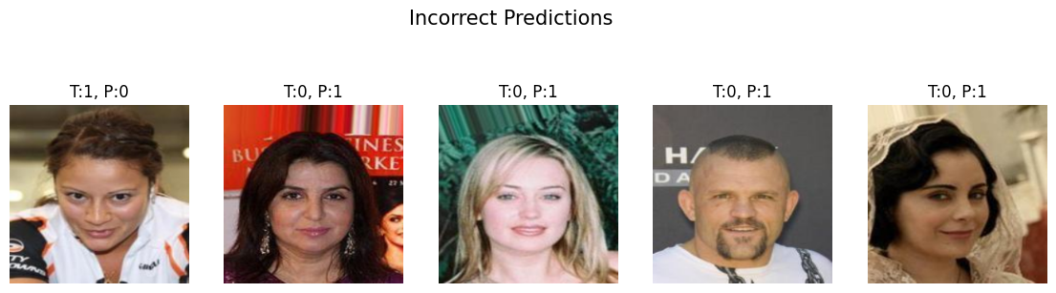

4. Discussion
4.1 Transfer Learning vs. Fine-Tuning
Our experiments confirm that Model B (Fine-Tuning) yielded better performance than Model A (Frozen).
- Pure Transfer Learning (Model A) relies on generic features learned from ImageNet (which contains objects, animals, vehicles, etc.). While these are useful for low-level edge detection, they are not optimized for fine-grained facial analysis.

- Fine-Tuning (Model B) allowed the weights in the final convolutional block to update. This is crucial because deep layers in a CNN capture high-level semantic concepts. By adjusting these layers, the model learned to focus specifically on features relevant to smiling (e.g., lip curvature, teeth visibility) rather than generic object shapes.
4.2 Impact of Data Augmentation
Data augmentation played a critical role in generalization.
- Horizontal Flipping taught the model that orientation does not alter the "smiling" attribute (a smile is a smile whether facing which direction).

- Color Jittering prevented the model from overfitting to specific lighting conditions or skin tones found in the training set, ensuring the model focuses on structural geometric features rather than color intensity.

4.3 Error Analysis
An analysis of the misclassified images reveals common failure modes:
- Ambiguity: Subjective expressions (e.g., a smirk or a person talking) were often confused with smiling.
- Occlusion: Hands or objects covering the mouth area prevented the model from detecting key features.
- Low Resolution/Blur: In some cases, poor image quality degraded the feature extraction process.
4.4 Conclusion
Fine-tuning the final convolutional block significantly improved validation and test accuracy compared to using VGG-16 as a frozen feature extractor. This demonstrates that adapting deeper layers to domain-specific attributes, such as smiling, provides a clear benefit over pure transfer learning.

